**Data Methodology for PPT 02**

**Step 1: Storyboarding**

* Examined the data to become acquainted with it and made a note of any significant fields.
* Made a mental map of the presentation's different slides.
* Enumerated all the characteristics for which graphs and charts must be plotted.

**Step 2: Data Wrangling**

* Imported the dataset in Python Notebook and go through the all the columns.
* Also checked the missing values in all the columns.

id 0

name 16

host_id 0

host_name 21

neighbourhood_group 0

neighbourhood 0

latitude 0

longitude 0

room_type 0

price 0

minimum_nights 0

number_of_reviews 0

last_review 10052

reviews_per_month 10052

calculated_host_listings_count 0

availability_365 0

dtype: int64

* Treated Missing values by using Python & attached the Python Notebook in zip file.
* Used Tableau to further visualize the modifications that were exported to a CSV file.
* Created some grouped field & calculated field.

**Step 3: Data Analysis**

* Since they appear to be in high demand, private rooms and entire homes/apts in Brooklyn and Manhattan should be the focus.
* Targeting shared rooms is a good idea because they already have low prices and will attract more clients if approached sensibly.
* 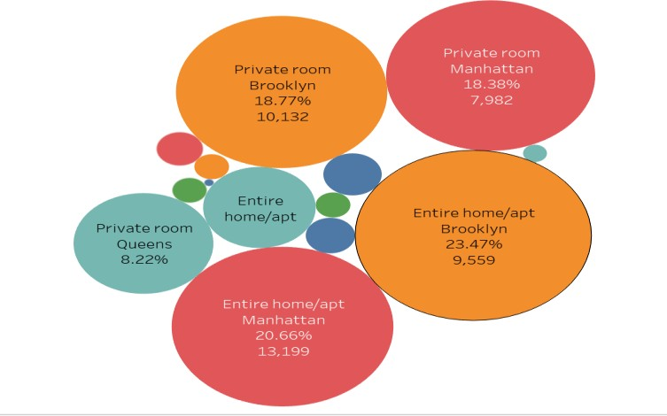Manhattan and Brooklyn have the costliest real estate compared to other areas
* In order to boost revenue, concentrate on expanding the listings in Queens, the Bronx, and Staten Island. Since Manhattan accounts for 90% of total revenue, hosts can lower the price to draw clients because it is the most popular listing on the list.

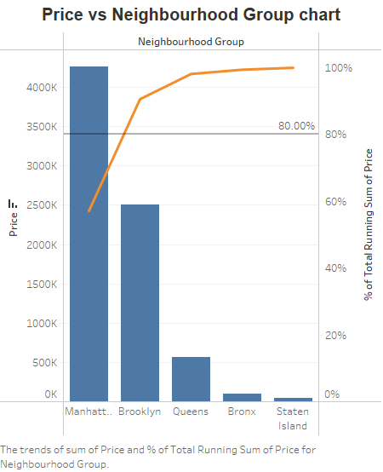

* Also attaching the Tableau workbook in zip file.

**Step 4: Presentation**

* Made the presentation using the pyramid approach and best practices.
* The people watching this are the **Head of Acquisitions and Operations** & **Head of User Experience**.
* Additional suggestions for the corresponding departments